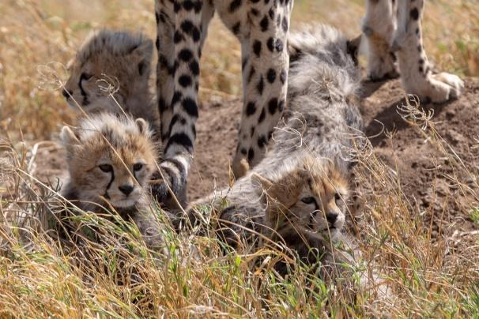
Photo by Jean-Daniel Calame on Unsplash

Objectives
Upon completing this lesson, students will be able to:
- discuss how intraspecies variation can change the reproductive success of an organism
- understand how extinction events and genetic bottlenecks are related

Materials
- Cheetahs: On the Brink of Extinction, Again article
- Cincinnati Zoo & Botanical Garden Cryobiobank website

Directions
Read the article Cheetahs: On the Brink of Extinction, Again then answer the questions below.

Questions
- How does the cheetah’s low rate of reproductive success affect the species long term survival?

- What is a bottleneck? How does a bottleneck event affect a population’s gene pool?

- What pieces of evidence show that cheetahs have low genetic variability?

- Why is this low genetic variability concerning to conservation biologists?

One way conservation biologists at the Cincinnati Zoo are trying to save species is by creating a Cryobiobank. Read about the animal samples stored in the Cryobiobank here.

- What is in the Cryobiobank?

- Why is the Cryobiobank important to saving species? Relate your answer to natural selection and evolution.

